

Software Engineering - CSCI 313 Project
Nile University Navigation System
Team:
Kirillos Ramzy (Team Leader) 231001656
Rodina Ahmed 231002758
Tasneem Ahmed Elsharkawy 231001397
Nardy Abdalla 231001653

Table Of Contents
1. Project Overview
1.1. Logo
1.2. Installation and Setup
2. Agile Methodology & Scrum Details
2.1. Kickoff Phase
2.2. Pre-Milestone Phase
2.3. Sprint Details
3. System Architecture
3.1. Code Structure
3.2. User Interface
3.3. Features and capabilities
4. Error Handling
5. Pathfinding Algorithm
6. Testing

- Project Overview
This project aims to help Nile university students; it is a user-friendly tool to help them navigate their way through their university life. It was not just wanted but needed, to save students’ time and effort and help them arrive at their goal destination, our goal was to solely be the helper students needed all along.
1.1 Logo:

The project's branding was intentionally designed to reflect its purpose:
Color Palette: The color blue was selected to represent the identity of "Nile" University.
Iconography: A pointer/pin symbol was chosen to universally communicate system's function as a pathfinding and location tool.
1.2 Installation and Setup:
To use the Website:
Access the application directly here: Nile University Navigation System
For Developers to clone and run locally:
- Clone this repository:
git clone https://github.com/Sa3id-jr/Nile-university-navigation-system.git
cd Nile-university-navigation-system
- Open the index.html file in your browser

- Agile Methodology & Scrum Details
2.1 Kickoff Phase
To guarantee a smooth start we managed to get together and brainstorm ideas and got to choose and plan this one after drawing a mind map to understand what will be needed in our project as we realized that blueprints will be needed during development
2.2 Pre-Milestone Phase
We made sure to hit every milestone with confidence and before phase one we had to complete the mapping of one floor , we drew the map ourselves and then we got some external help to transfer it on Autocad afterwards we made a design over it and made it more user-friendly and interactive.
2.3 Sprint Details
To ensure a successful delivery of the project we conducted an online daily meeting to ensure team alignment and the goal from these meetings was to make sure that we stay on the same page and exchange info and check tasks off our TODO list or as it is called in agile methodology “backlog”

3- System Architecture
The Nile University Navigation System follows a layered architecture with three distinct tiers, implementing a procedural programming paradigm with functional decomposition
3.1 Code structure
The Nile University Navigation System employs a monolithic single-file architecture, where all application code (HTML, CSS, and JavaScript) is contained within a single index.html file. This design choice prioritizes simplicity, ease of deployment, and offline functionality while maintaining clear logical separation between presentation, business logic, and data layers.
HTML Component Hierarchy
<body>
│
├── <button class="theme-toggle"> # Floating UI Element
│ └── SVG Icons (sun/moon)
│
├── <div class="offline-indicator"> # Network Status
│ └── Text: "Offline Mode"
│
└── <div class="container"> # Main Application Container
│
├── <div class="sidebar"> # Left Panel (380px)
│ │
│ ├── <div class="sidebar-header"> # Brand Section
│ │ ├── <div class="logo"> # NU Logo
│ │ └── <div>
│ │ ├── <h1> # Title
│ │ └── <p> # Subtitle
│ │
│ ├── <div class="status-bar"> # System Status
│ │ ├── <div class="status-dot">
│ │ └── <div class="status-text">
│ │
│ ├── <div class="floor-selector"> # Floor Toggle
│ │ ├── <button data-floor="ground">
│ │ └── <button data-floor="upper">
│ │
│ ├── <div class="search-section"> # Start Location
│ │ ├── <div class="input-wrapper">
│ │ │ ├── <div class="input-icon">
│ │ │ ├── <input id="start-input">
│ │ │ └── <div class="autocomplete-box" id="start-box">
│ │ │ └── [Dynamic: Suggestion Items]
│ │
│ ├── <div class="search-section"> # Destination
│ │ ├── <div class="input-wrapper">
│ │ │ ├── <div class="input-icon">
│ │ │ ├── <input id="end-input">
│ │ │ └── <div class="autocomplete-box" id="end-box">
│ │
│ ├── <button class="route-btn"> # Calculate Route
│ │ └── Text + Icon
│ │
│ ├── <div class="route-info-compact"> # Route Info Card
│ │ └── [Dynamic: Distance, Time, Transport]
│ │
│ ├── <div class="directions-panel"> # Turn-by-Turn
│ │ ├── <div class="directions-header">
│ │ └── <div id="directions-steps">
│ │ └── [Dynamic: Step Items]
│ │
│ ├── <div class="control-buttons"> # Action Buttons
│ │ ├── <button id="reset-btn">
│ │ └── <button id="clear-btn">
│ │
│ └── <div class="map-footer"> # Footer
│ └── Text: Version Info
│
└── <div id="map"> # Right Panel (Flexible)
└── [Dynamic: Leaflet Map Canvas]
JavaScript Code Composition
JavaScript :
│
├── Service Worker # PWA offline support
├── Data Structures # Rooms, waypoints, edges
├── Graph Building # Navigation graph construction
├── Dijkstra Algorithm # Pathfinding implementation
├── Route Calculation # Route coordination logic
├── Map Rendering # Leaflet.js integration
├── UI Event Handlers # User interaction logic
└── Event Listeners # DOM event bindings
CSS Organization
The CSS is organized into 7 major sections with clear separation of concerns:
CSS Structure
│
├── 1. CSS Variables & Reset
│ ├── Theme variables (colors, spacing, typography)
│ ├── CSS reset rules
│ └── Base element styling
│
├── 2. Layout System
│ ├── Flexbox container
│ ├── Sidebar (380px fixed width)
│ └── Map container (flexible width)
│
├── 3. UI Components
│ ├── Header & logo
│ ├── Status bar
│ ├── Floor selector buttons
│ ├── Search inputs
│ ├── Route button
│ ├── Autocomplete dropdown
│ ├── Directions panel
│ ├── Control buttons
│ └── Modals & notifications
│
├── 4. Map Styles
│ ├── Custom markers (start, end, transport)
│ ├── Animated polylines
│ ├── Leaflet popup customization
│ └── Marker animations
│
├── 5. Animations
│ ├── @keyframes pulse
│ ├── @keyframes bounce
│ ├── @keyframes dash
│ ├── @keyframes slideIn
│ ├── @keyframes fadeOut
│ └── @keyframes slideDown
│
├── 6. Theme System
│ ├── Dark mode (default)
│ ├── Light mode variables
│ ├── Theme toggle button
│ └── Smooth transitions
│
└── 7. Responsive Design
├── Mobile (< 768px)
├── Tablet (768px - 1023px)
└── Desktop (> 1024px)

3.2 User interface
UI Overview
The Nile University Navigation System features a modern split-screen interface with a fixed sidebar (380px) for navigation controls and a flexible map canvas for route visualization. The design implements a dark/light theme system with smooth transitions and responsive layouts.
  - Dark mode
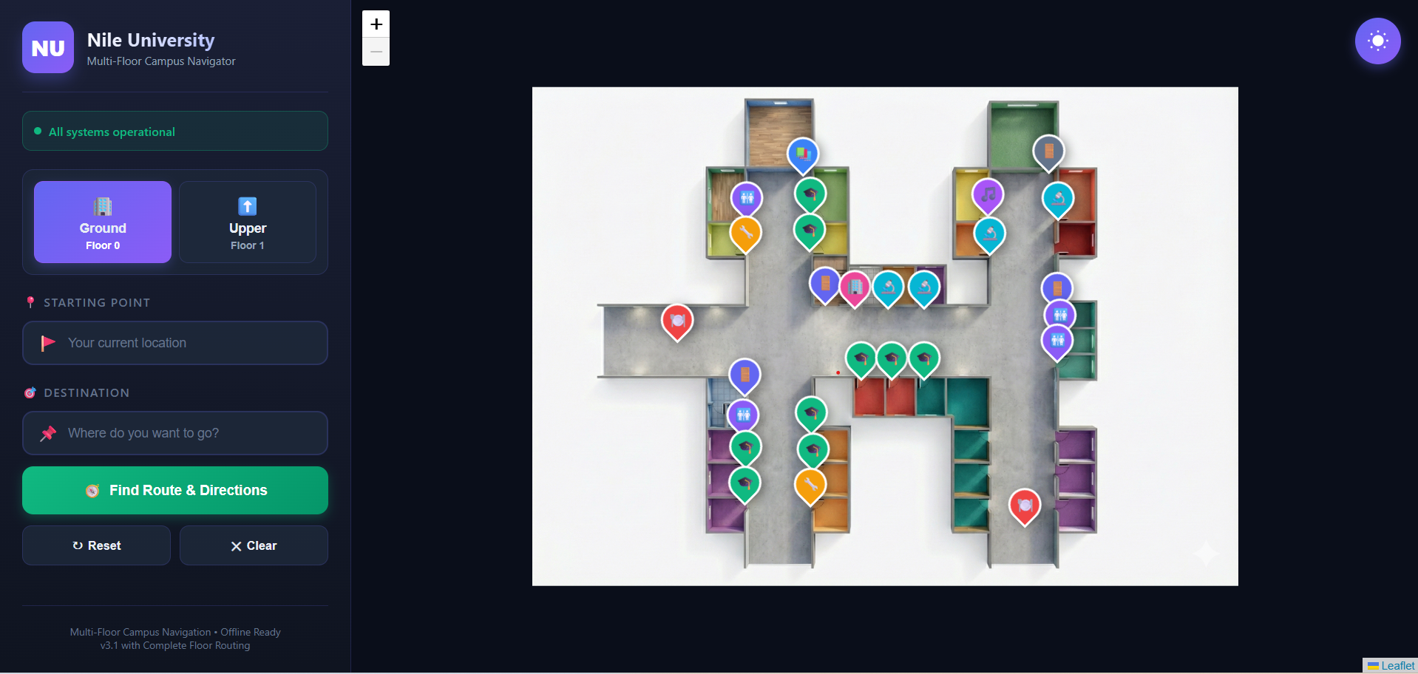
  - Light mode
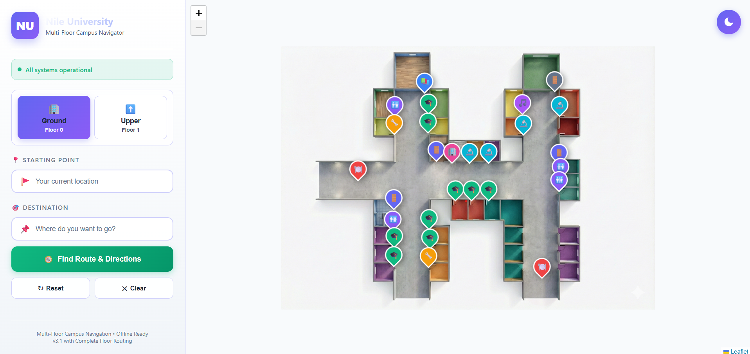
3.3 Core Features Overview
The Nile University Navigation System provides comprehensive indoor navigation with intelligent pathfinding, multi-floor support, and offline functionality. The system includes 10 major features organized into navigation, user experience, and technical capabilities.
NAVIGATION FEATURES (Core Functionality)
├── 1. Intelligent Room Search
├── 2. Optimal Pathfinding (Dijkstra's Algorithm)
├── 3. Multi-Floor Navigation
├── 4. Transport Selection (Elevator/Stairs)
└── 5. Turn-by-Turn Directions

USER EXPERIENCE FEATURES
├── 6. Interactive Map Visualization
├── 7. Real-Time Autocomplete
├── 8. Dark/Light Theme System
└── 9. Notifications

TECHNICAL FEATURES
└── 10. (Offline Support)

- Feature 1: Intelligent Room Search
Description: Real-time search system with autocomplete suggestions for quickly finding campus locations.
capabilities:
- Fuzzy matching - Case-insensitive substring search
- Category filtering - Visual icons for room types (📚 study, 🎓 classroom, 🔬 lab)
- Floor indicators - Badge showing room location (ground/upper)
- Limited results - Maximum 8 suggestions for performance
- Instant feedback - Results appear as user types (< 200ms)
- Click selection - Populate input field on suggestion click
- Feature 2 : Optimal Pathfinding (Dijkstra's Algorithm)
- Shortest distance
- Weighted graph - Real distance calculations (meters)
- Dynamic routing - Adapts to transport selection
- Corridor optimization - Uses waypoints for realistic paths
- Bidirectional edges - Two-way navigation support
- Fast computation - Routes calculated in < 100ms
- Feature 3: Multi-Floor Navigation
Description: Seamless navigation across building floors with automatic floor change detection and route segmentation.
Capabilities:
- Automatic detection - Identifies when route crosses floors
- Route segmentation - Shows path to transport point first
- Floor switching - Smooth transitions between floor views
- State preservation - Maintains route context during floor changes
- Continue workflow - User-confirmed progression to next floor
- Visual feedback - Transport marker indicates floor change point
- Feature 4: Transport Selection (Elevator/Stairs)
Description: User preference system for choosing vertical transportation method with route optimization.
Capabilities:
- Modal interface - Clear choice presentation
- Visual differentiation - Icons (🛗 elevator, 🚶 stairs)
- Route filtering - Graph edges filtered by transport type
- Accessibility consideration - Elevator option for mobility needs
- Alternative routing - Different paths based on selection
- Feature 5: Turn-by-Turn Directions
Description: Step-by-step navigation instructions with distance estimates and visual icons.
Capabilities:
- Distance per segment - Meters for each step
- Total distance - Cumulative route length
- Time estimation - Walking time
- Floor change indicators - Clear transport instructions
- Visual icons - Emoji-based directional cues
- Scrollable panel - Max 300px height, overflow auto
- Feature 6:Interactive Map Visualization
Description: Leaflet.js-powered interactive map with custom markers, animated routes, and floor overlays.
Capabilities:
- Zoom & Pan - Explore floor plans at multiple scales
- Custom markers - Color-coded pins (start/end/transport)
- Animated polylines - Moving dash effect on routes
- Floor overlays - High-resolution floor plan images
- Auto-fit bounds - Automatic zoom to show entire route
- Room popups - Click markers for location details
- Responsive canvas - Adapts to screen size

- Feature 7: Real-Time Autocomplete
Description: Instant search suggestions with category icons and floor badges.
Capabilities:
- Instant results - Suggestions appear as you type
- Category icons - Visual room type identification
- Floor badges - Location floor indicator
- Limited results - Top 8 matches for clarity
- Click selection - Auto-populate input
- Outside click close - Intuitive dismissal
- Keyboard navigation - Arrow keys + Enter (future)

- Feature 8: . Dark/Light Theme System
Description: User-customizable color themes with persistent preferences.
Capabilities:
- Two themes - Dark (default), Light
- Toggle button - Floating top-right corner
- Instant switching - 0.3s smooth transition
- Icon animation - Sun/moon icon transitions

- Feature 9: Notifications
Description: Non-intrusive feedback system for user actions and system status.
Capabilities:
- 4 types - Success, Error, Warning, Info
- Auto-dismiss - 3-second timeout
- Slide animation - Smooth entrance/exit
- Stacking support - Multiple notifications
- Icon-coded - Visual status indicators
- Non-blocking - Doesn't interrupt workflow
- High visibility - Fixed top-right position

- Feature 10: (Offline Support)
Description: Service Worker-powered offline functionality for campus navigation without internet connection.
Capabilities:
- Complete offline mode - Full app functionality without network
- Asset caching - Floor images, CSS, JavaScript cached
- Automatic updates - Refreshes cache when online
- Network detection - Online/offline status indicator

  - Error Handling
We managed to make sure that our system will not fail against many things such as empty user inputs, wrong room names , entering starting points or destinations that do not exist. We handled each case in an individual way to ensure the best user experience we can offer for each user.
The Error messages that gets displayed om top of the page in these cases:


  - Pathfinding Algorithm
Dijkstra’s Algorithm is the main star of our project as we employed the concept of finding the shortest pathway between two points to make sure we guarantee the user the most optimized and time saving route that exists. We planted dijkstra and found that it was a perfect fit for our system.
  - Testing
Testing Overview
The Nile University Navigation System employs automated testing to verify core functionality and ensure reliability. Tests run automatically in the deployment pipeline and can be executed locally for rapid feedback during development.
Test Categories
Asset Checks
Purpose: Verify that all required files exist before running the application.
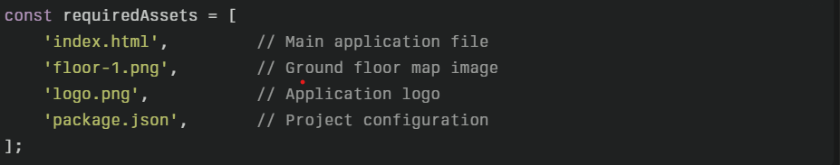

Test Implementation:
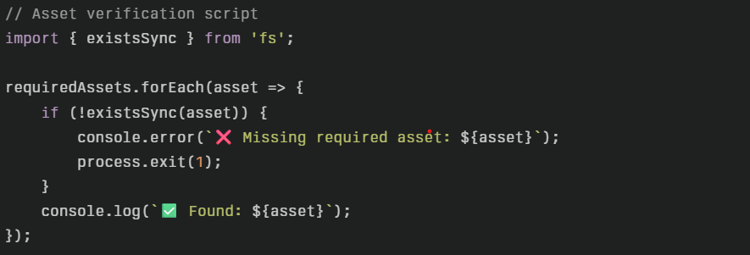
Results:
- All required files present in project root
- Floor map images accessible
- Configuration files valid
Why This Matters:
- Prevents deployment with missing assets
- Catches file structure issues early
- Ensures build artifacts are complete
Unit testing (vitest)
Purpose: Validate JavaScript environment and basic logic functionality.
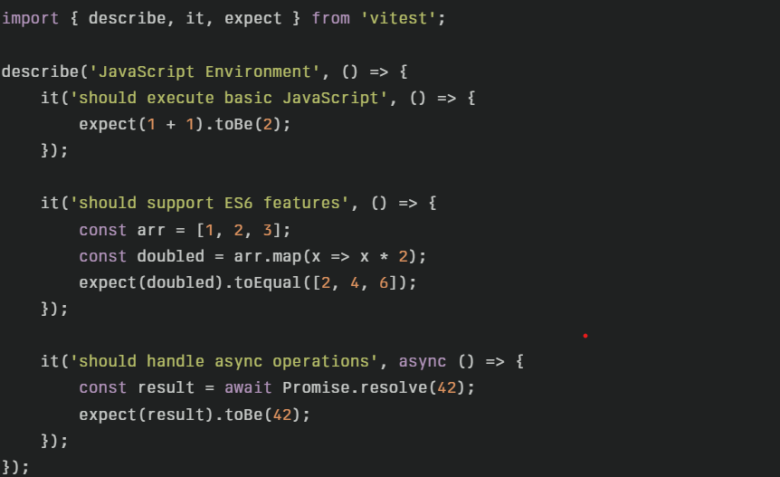
Results:
- Basic arithmetic works correctly
- Async/await operations function properly
- Test framework itself is operational
Algortithm testing 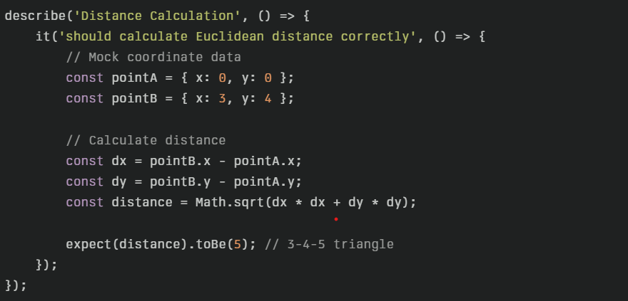
Testing UI & Validation Tests
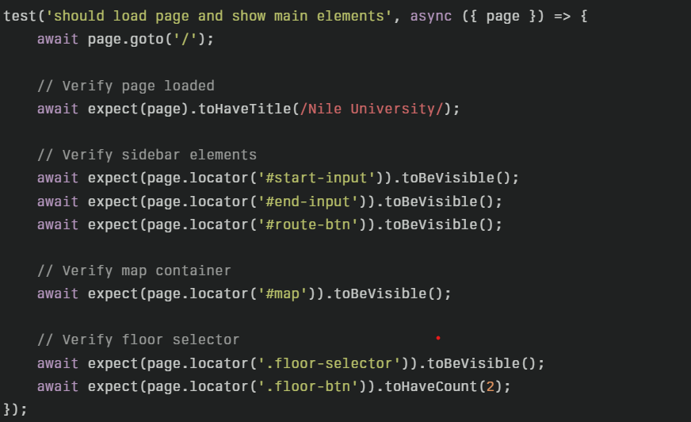
Results:
- Page title contains "Nile University"
- Start input visible and interactive
- Destination input visible and interactive
- "Find Route" button present
- Map canvas rendered
- Two floor buttons (Ground, Upper) displayed
Testing room validation
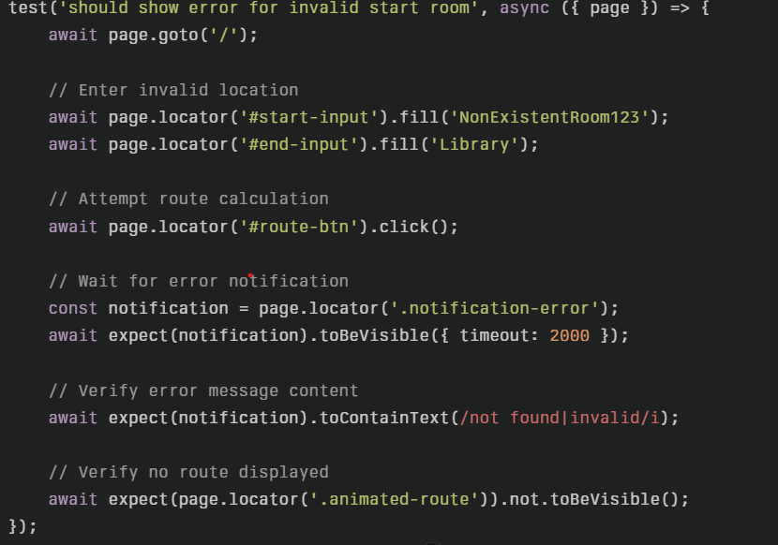
Results:
- Error notification appears within 2 seconds
- Message indicates location not found
- No route polyline displayed on map

Testing same room validation
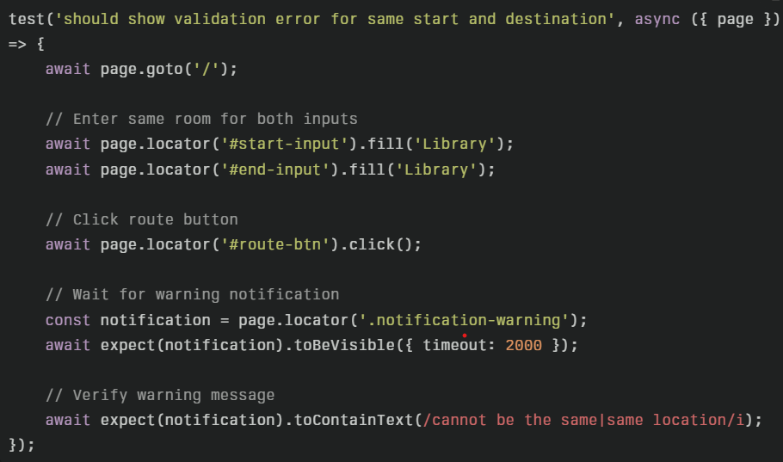

Results:
- Warning notification displayed
- Message explains validation issue
- Route calculation prevented

Testing from ground to upper floor
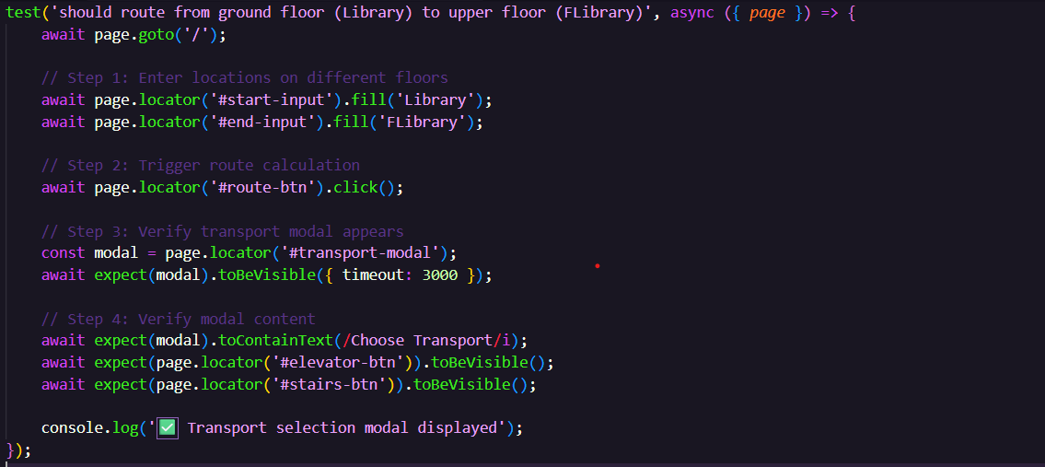
Results:
- System detects floor change (ground → upper)
- Transport modal appears within 3 seconds
- Both options (elevator, stairs) visible
- Modal includes descriptive text

Testing transportation selection
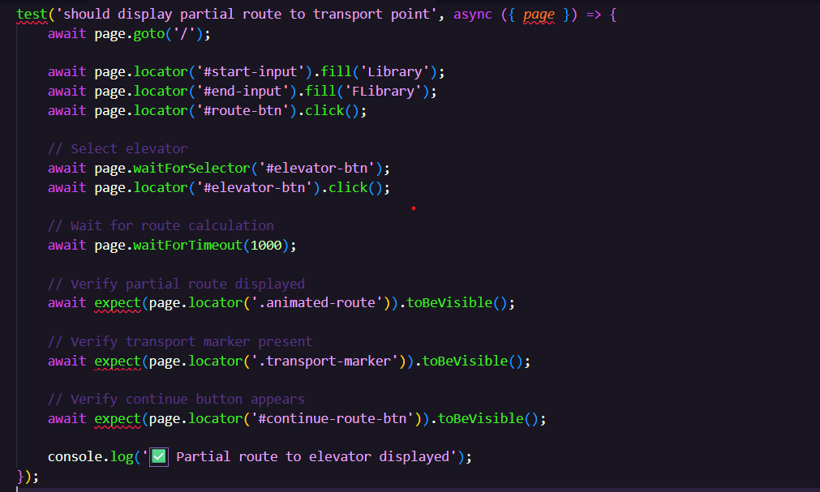
Results:
- Modal closes after selection
- Route polyline shows path to elevator
- Transport marker placed at elevator location
- "I've Arrived - Continue Route" button visible

Testing Offline Mode Tests (Playwright)
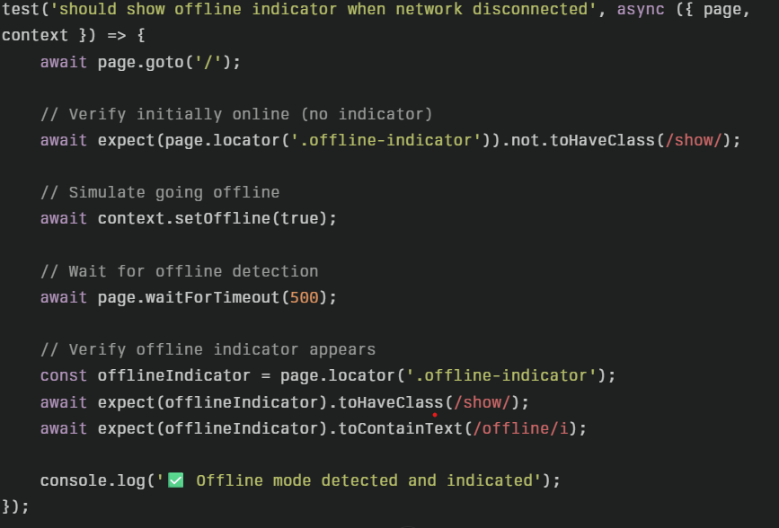
Results:
- Offline indicator hidden when online
- Indicator appears when network disconnects
- Message clearly states "Offline Mode"
- Detection occurs within 500ms

Testing Route Calculation While Offline
Objective: Ensure navigation works using cached data without network connection.
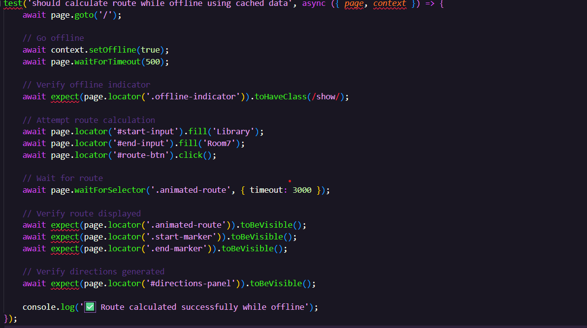
Results:
- Pathfinding algorithm runs without network
- Route polyline displays correctly
- Markers placed accurately
- Directions panel populated
- All data sourced from cache/memory

Testing Floor Switching While Offline
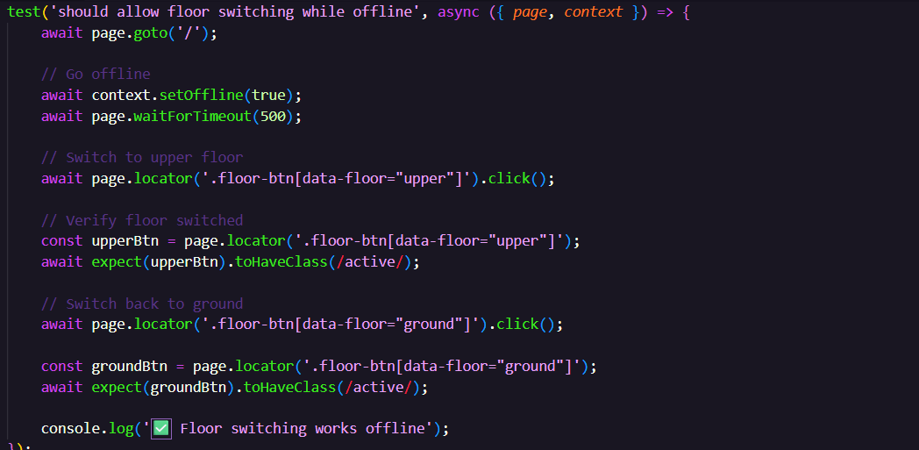
Results:
- Floor buttons remain interactive
- Map overlays switch correctly
- No network requests attempted
- UI remains responsive

Testing Route Clearing and Network Recovery
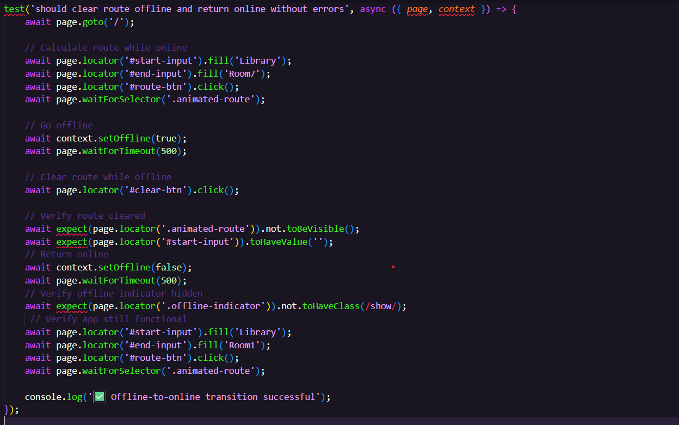
Results:
- Route clears successfully while offline
- UI state resets properly
- Network restoration detected
- Offline indicator disappears
- New route calculations work after reconnection

